HT Classification Results Analysis

# Context

## HT Cases Categories Definition



## Confusion Matrix

### Without normalization

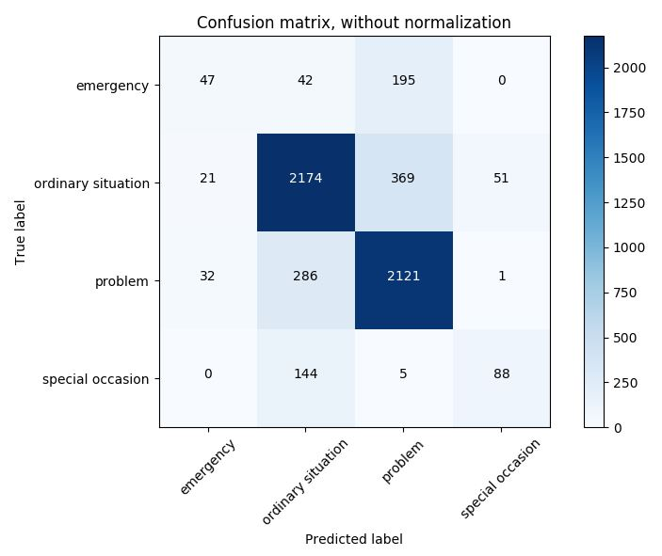

### With normalization

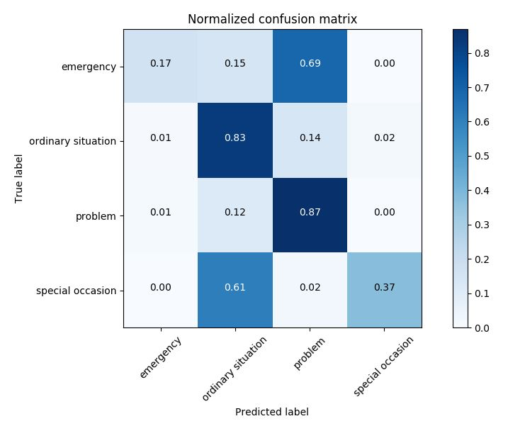

## Result Analysis

According to the confusion matrix, classification accuracy for major categories （ordinary situation and problem）are quite good. However, classification accuracy for emergency and special occasion are bad. Besides the lack of training data issue (only 284 emergency samples and 237 special occasion samples), we further looked into the data and wrong predictions to find out the reason of the bad classification results.

### Emergency (true label)

According to the Categories Definition, the sentences with **‘emergency’** and **‘urgent’** should have higher probability to be in emergency class, so that our CNN model will capture the keywords for this category.

However, we found that a large number of sentences with ‘emergency’ are labeled to belong to ‘Ordinary Situation’ and ‘Problem’ category. For example, in ‘Problem’ categories, we found 30 sentences that should be in ‘Emergency’ category, such as:

*Once my car was not working and I wanted to go somewhere so at night 11 pm they arranged a technician for me. When I called them so they said we closed our shop at 6 pm., but will do something for you as you have an emergency. I wanted to attend my board exam on next day.*

*I am going to other work, emergency I given to servicing my car, without appointment they taken my car. This was my Heart Touching experience.*

*Once without any appointment, they serviced my car at emergency period. This was a very happy movement.*

*One time I want to service my car in emergency, so in dealership have one person who came at night 9 pm & serviced my car. It was given me good feeling.*

*Once cars wire was cut by the rat on that day, I wanted to travel 250kms, then I called to Annamalai Trichy dealership, then the technician name Anthony brought one car with him and it was morning 7am. I have many cars like Tata, Ford and Honda but the Toyota helped me at the time of emergency, so I liked this.*

*In my cars water pump had some problem in it at that time leakage was there. At that time, I had to go Davangiri,then I called to the Ravindu daelership, they came immediately and helped me at the time of emergency. I wanted the car on that day only in emergency, they gave me at that day only and i lked this experience and it was good.*

*When my car tank got damaged, so I immediately went to the showroom the Millennium people repaired it very quickly & gave me. The rod was also hanging in my car, they repaired that was one experience I had & it was very grateful for me. It was very emergency & they did it immediately for me.*

*From Nippon Toyota service center, my office is very nearby distance 100-150mtrs only. Once, I was in office, when I came back to my car that time my car tire was punchered, so that time, I had an emergency meeting nearby my office location that location may be nearly 1-2 kms only from there I have to go very desperately, that time I called the service center & they were came to my office. Within few minutes, they repaired the puncher. This moment experience was very good for me because that time I had to attend that meeting.*

*My oil filter was fully damaged. I haven't got appointment from the service center, so I directly took my car to service center under emergency service. Within half an hour serviced my car. This was a very happy movement for me.*

*Once I was going somewhere and my car stopped on the way, so I contacted the service center and they immediately sent an emergency vehicle, it helped and they pulled my vehicle. I also reached with them. It was my very good experience with them*

*Once, my Innova car was dashed then I gone there & I had some emergency also that time, I required my car urgently after that I got my car on time.*

*I was stuck in an emergency, so I called and request to Mr, Abid and he helped me to drop my car at Saharanpur which was 300 KM.*

*I want to go emergency for some work in that time, I had problem with steering . The service staff came to my doorstep and serviced my car immediately this was a happy movement .*

We also found 20 sentences in ‘Ordinary Situation’ category but should be labeled as ‘Emergency’ category, such as:

*I had an emergency and I had not done booking by phone call and suddenly I visited the dealership and they had done my car servicing immediately. This I never thought that they will do my cars servicing.*

*During emergency, they give delivery of my vehicle within one hour.*

*Once, I given my car for servicing & when I gone there to take my car that was at night 9 pm & service center was closed & I had emergency because I want to go to hospital. The service center was closed, then too they delivered the car for me.*

*Once I had given my car for servicing in Lanson Toyota at that time, I was in hurry. I wanted to go some where and it was emergency. I asked them that will you do a quick service because I am in emergency, then they took the car at 10.30 am and they gave the car delivery at 11.30 am, so that thing I like a lot.*

*When I called them for booking an appointment for servicing the car, they said appointment is full and you will get an appointment after 2 days. But I requested them about the urgency and emergency. They took my car for servicing. So it was given me good feeling.*

*Once I needed an emergency service from Amana Toyota Malappuram, so I went there without any appointment. The service manager over there, he managed to get the service of the car at the same time. It was very helpful for me.*

*I was taken appointment for the servicing and I had go to Rajasthan in emergency. I request them and immediately they cooperate me and they servicing my car it make me happy, It?s not possible to go without servicing and I had go 300 KM.*

*It was an emergency, I needed the car as quick as possible. I requested them and they adjusted my appointment and within an hour. My car was serviced and they handed over it to me.*

*At emergency, my car wiper needs to be changed and that part was not available at dealership but still they changed the part. They took the wiper which needs to be delivered tomorrow and they fitted it in my car. This was a happy experience from the dealership.*

*My insurance paper were damaged because of the rats. It was an emergency to get my insurance paper, so I made a call in the service centre. I wanted the original papers because the other people don’t take the photocopy. I told them it is an emergency, so they immediately gave me the print of original insurance paper and they delivered to my office.*

These wrongly labeled samples will mislead our CNN model to make wrong predictions. That’s why a large number of samples are wrongly predicted to be ‘Problem’ and ‘Ordinary Situation’.

### Special Occasion (true label)

According to the confusion matrix, our CNN model confuses with ‘Special Occasion’ and ‘Ordinary Situation’. By looking into the labeling of ‘Special Occasion’ and ‘Ordinary Situation’, we found that there are many overlapping samples between these two categories.

For ‘Special Occasion’ category, keywords such as **‘gift’, ‘festival’, ‘birthday’, ‘photo’, ‘picture’, ‘coupon’, ‘celebrate’, ‘marriage’, ‘party’, ‘On … Day’, ‘event’, ‘ceremony’** should have high probability to invoke in this category. However,

For the keyword ‘birthday’, 71 samples are labeled as ‘Special Occasion’, however, 29 sample are labeled as ‘Ordinary Situation’.

For the keyword ‘festival’, only 5 samples are labeled as ‘Special Occasion’, however, 15 sample are labeled as ‘Ordinary Situation’.

For the keyword ‘marriage’, 11 samples are labeled as ‘Special Occasion’, however, 16 sample are labeled as ‘Ordinary Situation’.

Also, for the keyword ‘worship’ ceremony when purchasing the car, 70+ samples are labeled as ‘Ordinary Situation’, however, 17 sample are labeled as ‘Special Occation’.

For the keyword ‘gift’, ‘coupon’, ‘photo’ etc, we also found many overlapping between the two categories.

Besides, samples such as:

*On the day I purchased the new car and went to take delivery that time I felt so good. When they gave me the key of the new car, I felt so nice. Staff of dealer make me understood everything so nicely. Every documents they gave. I felt good for that.*

*They gave me instant delivery. The day I wanted the delivery of car the same day, they delivered. First they use to take time for delivery but this time when we went there they did the documentation in 10 minutes and immediately gave the delivery. Even the delivery location is good.*

*They welcomed us while purchasing the car.*

*During the purchase of the car the experience was heart touching. The delivery of the car was given in perfect time which was not expected and I was fully satisfied.*

*They worshipped our car at the time of purchase*

*When I visited for first servicing. They hang one welcome banner of my on there main gate that I like a lot. I have four car but not any service centre welcome me like this so I like it.*

*When I went to take the delivery of my new car, I wanted to do Pooja & it was raining heavily. As I wanted to do Pooja before taking the car so at that time one of the staff came with an umbrella & helped me to do the Pooja of my new car.*

*When I purchase my car, I told them that I will not able to come to showroom to receive the car I requested them to deliver my car to my residence at Vashind and they listen to my request and deliver it with proper procedure and I like it.*

*When, I visited the service center to purchase a new car, I told them I want the car to be delivered on a particular date, they arranged the car. Apart from this no dealer was ready to deliver it on the particular day.*

*Before buying the car, I had a test drive and this makes me feel good. This is a heart touching experience to me.*

*At the time of car purchasing, they were treated in a good way I feel very good I was not seen any person like this.*

Should be labelled as ‘Ordinary Situation’ but are labelled as ‘Special Occasion’.

Due to the inconsistency and overlapping labelling of ‘Ordinary Situation’ and ‘Special Occasion’, our CNN model cannot distinguish between these two categories.

## Summary

In conclusion, we found many labelling errors as well as inconsistent/overlapping labels of training data. In order to make better prediction for any machine learning model, the quality of training data plays a vital role. Our suggestion is to re-label the training data according to our analysis in section 1.3, to make the samples in one class distinguishable from other classes.

# Content

## HT Cases Categories Definition

|  |  |  |
| --- | --- | --- |
| Service Content | Roadside Assistance | -There was an issue with the radiator and the car stopped on my way back from the office. I called the service centre. They came in half an hour. I'm very delighted with the fact that they are available whenever we call them. |
| Quick Service | -When I was at the dealer for servicing, there were a lot of cars for servicing at the dealer shop. However, the DLR staff asked service staff to fix my car despite of their ongoing work. They are very much helpful. They gave me the delivery on time. |
| Personal Need | - I did not have any appointment with the DLR. However, they accepted my car and fixed the issue. - Once I was at the DLR for servicing. My phone battery was low and I had to make urgent business calls. The manager there let me used his charger. |
| Snacks | - Whenever I go to the showroom, they serve me water and tea which is a very good gesture and I find it heart touching. |
| Forgotten Stuff | - I forgot my wallet at the dealer shop but the dealer returned it back to my home |
| Detailed Explanation | - The staff explained the process and service details very well - The staff explained why there were differences between estimated service cost and the actual service cost |
| Pickup/ Drop | -I went to give my vehicle for servicing at that time, they dropped me till my work place in their vehicle. This was heart touching for me. |
| Gift | - Once the officials called me and said that they wanted to meet me. They came and gave me a gift which I liked. It shows that they make an effort to maintain relationship. |
| Free Service/ Discount | - There is package of servicing. One package is of Rs. 30,000. If we take car for servicing and we have only Rs.10, 000. Then they asked me to pay 10,000 now and remaining later |
| Dealer Event | - They were having their launching, so that time they called us with all family members for the launching event and also took pictures with all of us and also first of all they give the car to us only. |
| Issue Resolution | - There was a problem with the suspensor, they have fixed the issue. |
| Care from Staff | - The thing is that sometimes the service manager takes personal cares on your car. I accidentally hit the platform and I got a dent on my bumper. The manager from the dealer shop offered me tea and snacks and tried to comfort me that it happens sometimes and not a big issue. Plus, they fix it in no time. |

## Confusion Matrix

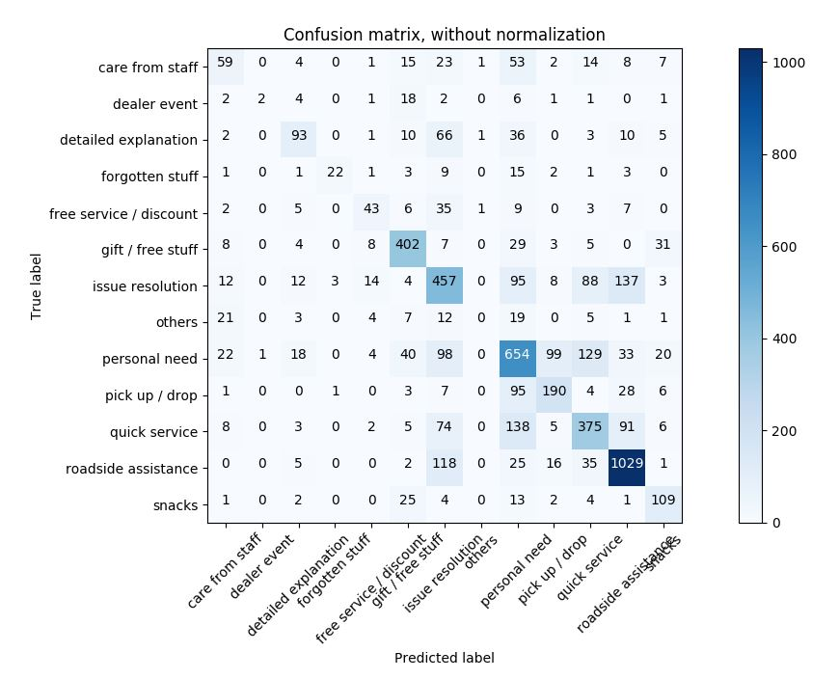

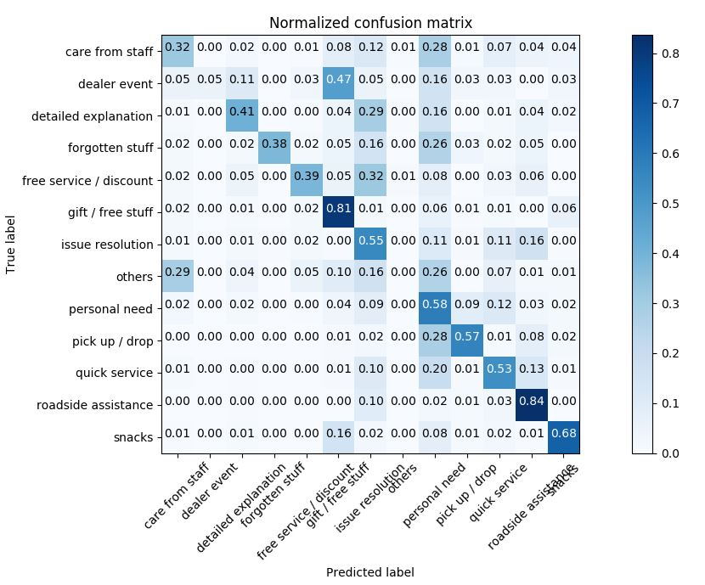

## Result Analysis

Regardless of the good performance obtained from two categories (i.e., gift/free stuff and roadside assistance), we discuss the results of other 10 categories that are somehow unsatisfactory into detail.

### Care from staff

According to the Categories Definition, staffs take care of customers' issues as their own or show empathy to the customer regarding their problem reflect “care from staff”. However, we find it is very ambiguous to clarify the “care” from the perspective of personal care and problem resolution. As a result, the predictions of “care” are highly confused with the categories of “personal need” (64/188 sents wrong). For example,

*When my accident happened, they helped me a lot. They send crane at my home and they take car by themselves at service center. They offered me coffee. They gave me car on time. ---personal need*

*I didn't take any appointment for the service but they attended me fast and nicely. They supported me very much. I live in Uttrakhand and I went to Delhi for service. They did it within few hours. I have a good experience with them. ---personal need*

To our knowledge, the above two “inaccurate” results are actually true for the category “personal need” based on the definition of it. In addition, this category is somehow confused with the category “issue resolution” (25/188 sents wrong). It is not hard to understand in terms of the essence of staff caring which is help clients resolve their problems. Therefore, we recommend to ensure all the sentences containing water, coffee, tea, etc. offered by staffs to be labeled to “personal need” and other problem solving sentences to “issue resolution”.

### Dealer event

According to the confusion matrix, the 38 dealer event category is a very small class. The performance is really poor and most of the sentences are predicted to the category of “gift/free stuff”. The reason can be explained by the fact that gifts or free stuffs are always associated the dealer event or promotion occasions. So our CNN model is not very sensitive to the event itself due to the small volume of data samples of this category.

We also found there existing many labelling errors in the existing annotations. We list **all** sentences that our model predicted correctly while the “true labels” are obviously wrong (highlights are predicted results):

*On 6th March it was Women's Day. They had call me & told that today you can do the free service. So I feel very good for that. ---free service*

*One day when I go to the dealership that time they are invite to my family & arrange the event. They are give them some snacks to my family. That event my family was much enjoyed so that is very heart touching for me. ---snacks*

*My car having some problem they recall me & solve my problem I like it. ---issue resolution*

*When I went for my car servicing, there was a free servicing offer & AC of my car was not working properly so the fixed the issue by which I was very happy. ---issue resolution*

*I do not know to drive the car. They called me once and said that there is a camp in Karad, so I told them I cannot drive the car and my son is also not there then they said we will collect your car just give the keys and we would resend the car after servicing. This experience was good. Now they took the car and did the check up in systematic way even though i do not know to drive. ---pickup/drop*

*I had bought 2nd hand car and I was not aware that the status of the car is not good but the repaired the car & made it in a good condition. This was a very good experience for me. One more thing was that they helped me in making all the details of the car in my name. So this was a heart touching experience for me. ---detailed explanation*

*First time, when I went there I was very satisfied but second time I settled bill may be not paid it.Something for satisfactory I ranged a bell so every one got up and clapped which I liked a lot.When I appreciated them they also gave me a good response.I had gone there to pay the bill for the gate pass that time they said that if I am satisfied then i can ring the bell and then they would understand that customers are happy.So i rang the bell which i liked it. ---detailed explanation*

*My car is Innova they attached Allies car tyre in my car they don't now about it. After a year they change it. When they change the tyre they did not take charges from me because it was there mistake. So it was my good experience. ---free service*

*Sonak Toyota dealership had kept party for completing of one year of the Innova Crista car. In that party, they also invited me. In big hoarding were with family title in that my name was also there. In family hoarding, I was also one member of it. By seeing all this, I felt good. They treat their customer as their family. The employees also keep brotherhood relationship with the customers. ---care from staff*

After the labelling correction, we can rerun the model to see the improvements, yet the per-class performance may not improve to 50%+ due to the data limitation.

### Detailed explanation

The most confusing category with respect to this category is “issue resolution” (53/227 sents wrong). This is because the narrations always end up with problem resolution even though there are some “explanations” within them. For example, *In 2016, my car accident will be lapped. I visit the service centre with my car. There are telling me the whole procedure about the car estimate & servicing my car quickly this service I like very much. This far of any expectation level.* We observe “explanation” and “resolution” appear in this review at the same time.

### Forgotten stuff

According to the confusion matrix, the 58 dealer event category is a very small class, and many samples are predicted to the category of “personal need”. The limitation of data samples is the main reason of low performance. The keywords such as **left, return, cash, purse, phone, keys** are not very salient compared to the other categories who have much more data samples.

### Free service/ discount

The most confusing category with respect to this category is “issue resolution” (28/111 sents wrong). The reason is that most of the mislabeled data are associated with issue resolution at lower or free cost. Thus, it will certainly confuse the model while “issue resolution” is a large set of category in classification. Meanwhile, we find some sentences that our model predicted correctly while the “true labels” are obviously wrong. We list **some** examples here and more detailed check is worthy in terms of per-class accuracy improvement (highlights are predicted results):

*When I went to take my car, then they had cut the cake, everyone was gathered and clapping for me. So I like it very much. ---gift/free stuff*

*When, I was purchase the car after 2-3 months, there have manufacturing problem in my cars tire. The dealers gave good response and change my car tire. ---issue resolution*

*One day I thought my cars rear pender damaged by mistake with me. My cars spare is at upside the mirror .Again I thought it is damaged at Toyota by mistake servicing time. Then after I know it was my car driver mistake. After I complained at Toyota, In servicing my car then you are damaged my car rearpender. After they are told me taken away my car at service center. So they are change it Immediately and returned my car. After my driver told me this mistaking him. After I went at Madhuban to paid my payment then I told them. After my driver told me this mistake him ,After I went Madhuban Toyota paid my payment .Them t told them my drivers mistake ,But they are not taken the payment .I am not expected madhban Toyota staff are agreed .There Mr.shreekant sir is repaired my car with in a day. I told them again taken the payment but they told me next time we are adjusted .hence I will very happy. This was my heart touching experience. ---issue resolution*

*In car have leather seat which was not work properly. Driver has to pull front side to get comfortable, we given a complaint after that there officer came & he told to remove this leather seat then we removed leather seat and also which charges they taken for leather seat they return back to me. ---issue resolution*

*Always, there is a problem in the car. It gets stopped any time and I canÂt understand what is the exact issue in the car. My car completed 1 lakh kms. I went at the service center to do the servicing of the car. The staff told me, my car is out of warranty and due to this problem were there in the car. They checked, my car record and did the adjustment and did the car servicing in warranty. ---issue resolution*

### **Issue resolution**

This category contains 833 data samples based on the current labeling. According to the confusion matrix result, this category is confused with “quick service” (77/833 sents wrong) and “personal need” (134/833 wrong). Intuitively, “issue resolution” and “quick service” are naturally correlated. However, when looking at the prediction results, we find many sentences should be labeled as what we predicted instead of the original label: issue resolution. For example,

*Once, I had gone to service centre with my family and it was closing time of service center. Shockup of my vehicle was not working, so they replaced it within an half hour before the 6 pm so it was a heart touching moment for me. ---quick service*

*My car broke down once at that time, the Anaamalai dealership serviced my car quickly. This was an unforgettable experience from the dealership. ---quick service*

*Once we went to Kolkata to attend marriage function and my car was having some issue. So we went to nearby service center and we told him our problem that we have to attend marriage function so within 30 min they repaired the car. ---quick service*

*My car met with an accident. My car back bumper need to be changed. The dealership serviced my car within 3 days instead of taking 10 days to service the car. This was a good experience from the dealership. ---quick service*

*We had a small accident with the car & my husband was abroad & was supposed to come back on that evening. Before giving the vehicle for servicing he needed to sign the insurance form. So they personally dropped the documents by which we were very happy. ---personal need*

*Whenever I planed for travel they attend me without appointment. ---personal need*

*I had admitted my son in hospital and it was very emergency and my car was having a small issue. I requested the service centre to look after my car and I have emergency and they promptly fixed my car thus I felt so much happy in their service. ---personal need*

Combining the two observations, we recommend to check the original labeling based on the prediction result attached. In addition, we suggest that this category is very general compared to other categories and should be further divided to the other 12 categories.

### **Personal need**

This category of “personal need” owns a large enough set with 1118 data samples. As shown in the confusion matrix, the confusing categories of it are “issue resolution” (78/1118 sents wrong), “pickup/drop” (90/1118 sents wrong), and “quick service” (120/1118 sents wrong).

To the mislabeled “issue resolution”, the predicted results are very difficult to judge because most of them include the conceptual “resolution”-related content. For example, *Last time, in my car noise was coming in bearing, it was closing time of dealership at 5 pm, so I called the manager & told my problem & requested them to complete the work today only. After that they changed the ball bearing & also noise was stopped. They done my work immediately, so it was given me good feeling.* As the suggestion given in 2.3.6, this is either the issue of incorrect labeling of “personal need” or merge the concept of “issue resolution” into more detailed categories such as “personal need”.

To the mislabeled “pickup/drop”, the true labels are poorly annotated because most of the predictions contain the keyword **pickup, drop**, which exactly match the example comments that labeled as “pickup/drop”. For example, *Once I went to give my vehicle for servicing and I did not have any vehicle to come back so the executive gave his own vehicle and also dropped me back*. From this aspect, our “mislabeled” predictions are actually correct, while the problem is caused by the “true” labels offered.

To the mislabeled “quick service”, we also find the inconsistent issue on the true labels as our predictions are actually correct in many cases. For example, *The people are courteous. They are helpful. They ask the problem immediately and listen to it carefully and whenever I went, I get a special attention*. Thus, please carefully check the labels based on the prediction results in the .csv file.

### Pickup/ drop

The most confusing category is “personal need” (123/335 sents wrong). This is because the customer service occurring during pickup/drop usually accounts for the personal need of the customers. For example, *After dropping car for service had to go to temple. So the service advisor dropped all of us to the temple. These was very happy moment* or *I left my car at service center for 2 days and I needed my car very urgently for some work that time, the dealership people arranged for me another car. This made me to feel happy*. It is very ambiguous to categorize these comment because the pleasant experience of pickup/drop is due to the issue resolution of the customers’ personal need. Moreover, we state that mislabeling issue on the large “personal need” category impacts on the prediction results of smaller “pickup/drop” category based on the observation on 2.3.7. Thus, the per-class performance on “pickup/drop” category will naturally boost once the labelling on “personal need” is improved.

### Quick service

The most confusing category is “personal need” (173/707 sents wrong). To our surprise, we find that some mislabeled comments include keyword **appointment** that fulfils the definition of “personal need”, e.g., *One time I want to go out. In service center without appointment they don't check the car. My car appointment was not there then also they had done it quickly. So it was my good experience.* We believe the labeling of this category need to be re-checked for further improvement.

In addition, the labelling strategy of “quick service” need to be more precise because it may confuse with “roadside assistance”. We observe some mislabeled comments such as *Once I called up the road side assistance because I caught an accident. The technician came promptly and delivered my car in dealership within one hour*. We believe this can be labeled into “roadside assistance” as well.

### Snacks

The most confusing category is “gift/free stuff” (23/167 sents wrong). This result is not hard to explain and we question the necessity of having this category. It can be merged to gift/free stuff.

## Summary

In conclusion, we find many labelling errors (labeled into wrong category) in terms of the definition of categories offered in Exercise_Classification of HT cases_Definitions+Analysis template_Feedback.xlsx. You might need to carefully check the labels based on the above analysis and the .csv prediction results attached. Besides, we also find some comments involve multiple labels such as *Once I called up the road side assistance because I caught an accident. The technician came promptly and delivered my car in dealership within one hour.* It can be labeled into either “roadside assistance” or “quick service”. Our suggestion is that you can either standardize the labels to unique labels or keep two labels to these comments.

To our knowledge, the major problematic categories are two large sets that are elaborated in 2.3.6 issue resolution and 2.3.7 personal need. The labels require much more careful check to improve the overall performance.